Table of Contents

Criteria 2

Code 3

Conclusion 7

# Criteria

For task 2 I had to make a program that would calculate the price (including VAT) of the painting job. My program can generate a price by asking the user for the amount of rooms that need painting, if the rooms have wallpaper, the number of walls in each room, and the dimensions of each wall.

# Code

I started by importing the time module and creating empty variables and strings that I would use in subprograms later.

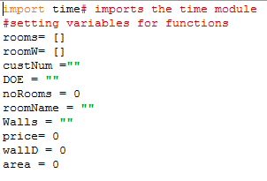

Then created my first function which I called “welcome” and giving the function access to variables outside the function by using the global statement.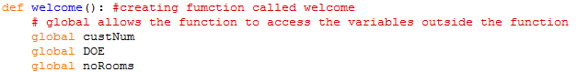

I displayed and welcome message and asked the user to enter the customer number and how many rooms they wish to paint.

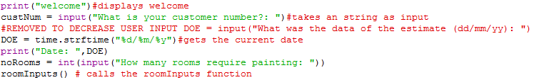 Part of the criteria was to get the date when the user started a new estimate I first did this by asking the user to enter the date but then used the time module to get the date. This reduced the user inputs so it reduces the amount of errors possible.

Next I created a function call “roomInputs” and giving the function access to variables outside the function by using the global statement.

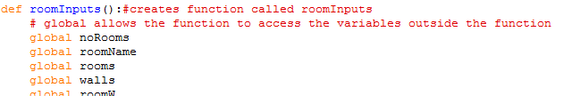

To take the details of each room I created a for loop to loop for the number of rooms the user wanted to paint.

I then displayed a message asking the user to enter the name of the room and appending the name entered to the list rooms.

I had to display and take the input of the room name separately because it would create an error when I combine the input with the message. The letter “i” in the message is the current number of loops and I added 1 to it because it would be confusing to the user when they are asked to enter the name of the room. For example on the first loop the message would display as “please enter the name of room 0” it is easier to understand when says “please enter the name of room 1” when talking about the first room.

The criteria said that I had to ask the user if the rooms had wallpaper. If they did then I had to add 70 to the price.

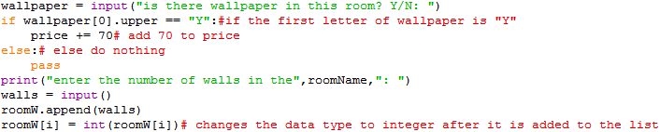

I used an if and else statement to check the user’s input. I checked their input by capitalising the first letter of the variable wallpaper and comparing the first letter to the letter “Y”, if they were the same then it would add 70 to the price, if they were not the same then it would do nothing and continue.

I also had to ask the user to enter the number of walls in each room.



I saved the user’s input in the variable walls then appended walls to the list roomW which would hold the number of walls for each room.

To start calculating the dimensions of the walls in each room I created a function called “ADroomInputs” and again used the global statement to give it access variables outside the subprogram.

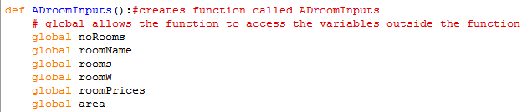

To find the dimension of the walls in each room I created to loops that would ask the user for the height and width of the walls.

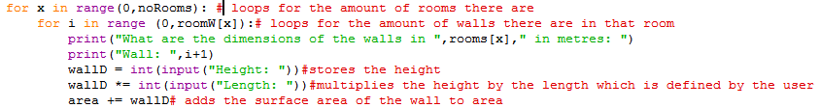

I had to create two loops, one was to get the room and the second was to get each wall separately. I used the loop variable x to get the number of walls in each room for the second loop. The user enters the dimensions which are then multiplied and added to the area.

Once the total surface area of the walls were calculated the price had to be calculated. I created another function called “pricing” and used the global statement to allow the function to interact with variables outside its scope.

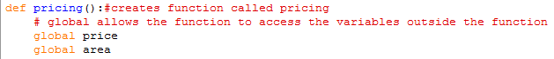

Area is the total surface and the price is the total price.

To get the price of the of the surface area I multiplied the surface area and added it to the variable price.



The user had to be given the option to select the type of employee they wanted and this would be added to the price.



When the user has entered the type of employee I checked they’re input using an if and elif statement. The first letter of the user’s input is capitalised and compared with the letters “A” and “F”. If it is “A” then 100 is added to variable price, if it is “F” 250 is added to the variable price.

The program then displays the price of the job with and without VAT.



I then created a function that would ask the user if they wanted o generate another estimate. I called this function “exORa” meaning exit OR again.

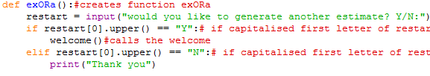

The user’s is saved in the variable restart and the first letter is capitalised and compared with the letters “Y” and “N” in an if and elif statement. If it is “Y” the function calls the welcome function. If it is “N” “Thank you” is displayed and the program ends.

I separated my program into subprograms to make it easier to read and I would be able to recall sections of the program to test them separately. At the end of each subprogram another function is called to access another section of code. Splitting up my program into sections also made it easier to work with as I didn’t have to worry about ruining different sections of my code and made it easier to find a specific piece of code.

# Conclusion

The program meets the criteria as it is able to find an estimate for any number of rooms the user inputs without problems. However if the user wants to get an estimate for a lot of rooms the program can becoming confusing as some sections loop for the number of rooms cluttering the inference. The program also doesn’t validate user input so if the program is expecting integers and the user provides a string it will cause an error however validation was not part of the criteria.

How did you address any difficulties you came across?

What were you thoughts on your program outcome?